MG6088 SOFTWARE PROJECT MANAGEMENT

ASSIGNMENT

ASSIGNMENT- I

Outline the step wise project planning activities using a diagram and explain in detail.

ASSIGNMENT- II

Describe the framework for dealing with risk.

ASSIGNMENT- III

Illustrate organization and team structures inn software project management?

ASSIGNMENT- I

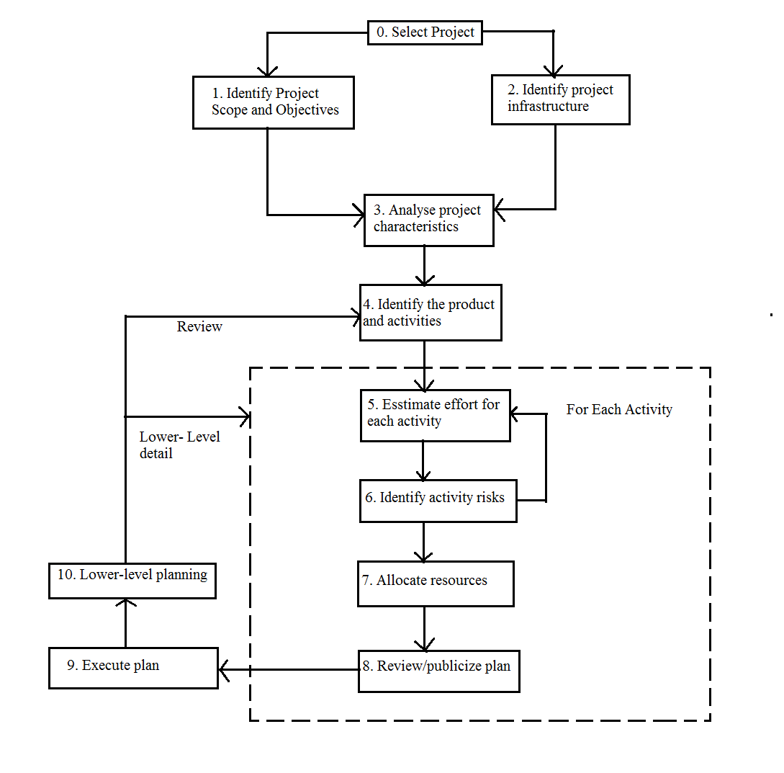

Step 0: Select Project
Step 1: Identify project scope and objectives
Step 1.1 : Identify objectives and practical measures of the effectiveness in meeting those objectives
Step 1.2 : Establish a project authority
Step 1.3 : Stakeholder analysis - identify all stakeholders in the project and their interests.
Step 1.4 : Modify objectives in the light of stakeholder analysis.
Step 1.5 : Establish methods of communication with all parties.
Step 2 : Identify project infrastructure
Step 2.2 : Identify installation standard and procedures
Step 2.3 : Identify project team organization
Step 3 : Analyse project characteristics
Step 3.1 : Distinguish the project as either objectives- or product-driven.
Step 3.2 : Analyse other project characteristics
Step 3.3 : Identify high-level project risks
Step 3.4 : Take into account use requirements concerning implementation
Step 3.5 : Select development methodology and life-cycle approach
Step 3.6 : Review overall resource estimates
Step 4 : Identify project products and activities
Step 4.1 : Identify and describe project products
Step 4.2 : Document generic product flows
Step 4.3 : Recognize product instances
Step 4.4 : Produce ideal activity network
Step 4.5 : Modify the ideal to take into account need for stages and checkpoints
Step 5 : Estimate effort for each activity
Step 5.1 : Carry out bottom-up estimates
- distinguish carefully between effort and elapsed time
Step 5.2 : Revise plan to create ontrollable activities
- breakup very long activities into a series of smaller ones
- bundle up very short activities
Step 6 : Identify activity risks
Step 6.1 : Identify and quantify activity based risks
- damage if risk occurs
- likelihood if risk occuring
Step 6.2 : Plan risk reduction and contingency measures
- risk reduction : activity to stop risk occuring
- contingency : action if risk does occurs
Step 6.3 : Adjust overall plans and estimates to take account of risks
Step 7 : Allocate resources
Step 7.1 : Identify and allocate resources
Step 7.2 : Revise plans and estimates to take into account resource constraints
Step 8 : Review/ Publicize plans
Step 8.1 : Review quality aspects of the project plan
Step 8.2 : Documentr plans and obtain agreement
Step 9 and 10 : Execute plan. Lower levels of planning

ASSIGNMENT- II

Planning for risk includes the steps:
- Risk identification
- Risk analysis and prioritization
- Risk planning
- Risk monitoring

Risk identification
Top-Ten List of Software Risk Items
1. Personnel shortfalls
2. Unrealistics schedules and budgets
3. Developing the wrong software functions
4. Developing the wrong user interface
5. Gold plating
6. Continuing stream of requirement changes
7. Shortfalls in externally furnished components
8. Shortfalls in externally performed tasks
9. Real-time performance shortfalls
10. Straining computer-science capabilities

Brainstorming

Risk assessment

Risk exposure (RE) = (potential damage) x (probability of occurrence)
IdeallyPotential damage: a money value e.g. a flood would cause $0.5 millions of damage

Probability 0.00 (absolutely no chance) to 1.00 (absolutely certain) e.g (one in hundred chance)RE = $0.5m x 0.01 = $5,000
Risk planning

Risk acceptance
Risk avoidance
Risk reduction
Risk transfer
Risk acceptance – the cost of avoiding the risk may be greater than the actual cost of the damage that might be inflicted
Risk avoidance – avoid the environment in which the risk occurs e.g. buying an OTS application would avoid a lot of the risks associated with software development e.g. poor estimates of effort.
Risk reduction – the risk is accepted but actions are taken to reduce its likelihood e.g. prototypes ought to reduce the risk of incorrect requirements
Risk transfer – the risk is transferred to another person or organization. The risk of incorrect development estimates can be transferred by negotiating a fixed price contract with an outside software supplier.
Risk management
Contingency
Deciding on the risk actions

ASSIGNMENT- III
Organization structure
Usually every software development organization handles several projects at any time. Software organizations assign different teams of engineers to handle different software projects. Each type of organization structure has its own advantages and disadvantages so the issue “how is the organization as a whole structured?” must be taken into consideration so that each software project can be finished before its deadline.
Functional format vs. project format

There are essentially two broad ways in which a software development organization can be structured: functional format and project format. In the project format, the project development staff are divided based on the project for which they work. In the functional format, the development staff are divided based on the functional group to which they belong. The different projects borrow engineers from the required functional groups for specific phases to be undertaken in the project and return them to the functional group upon the completion of the phase.
Advantages of functional organization over project organization
Even though greater communication among the team members may appear as an avoidable overhead, the functional format has many advantages. The main advantages of a functional organization are:
• Ease of staffing • Production of good quality documents • Job specialization • Efficient handling of the problems associated with manpower turnover.
Matrix format
Team structure
Chief programmer team
n this team organization, a senior engineer provides the technical leadership and is designated as the chief programmer. The chief programmer partitions the task into small activities and assigns them to the team members. He also verifies and integrates the products developed by different team members. The chief programmer provides an authority, and this structure is arguably more efficient than the democratic team for well-understood problems. However, the chief programmer team leads to lower team morale, since team-members work under the constant supervision of the chief programmer. This also inhibits their original thinking. The chief programmer team is subject to single point failure since too much responsibility and authority is assigned to the chief programmer.
Democratic Team
The democratic team structure, as the name implies, does not enforce any formal team hierarchy. Typically, a manager provides the administrative leadership. At different times, different members of the group provide technical leadership.
The democratic organization leads to higher morale and job satisfaction. Consequently, it suffers from less man-power turnover. Also, democratic team structure is appropriate for less understood problems, since a group of engineers can invent better solutions than a single individual as in a chief programmer team. A democratic team structure is suitable for projects requiring less than five or six engineers and for research-oriented projects. For large sized projects, a pure democratic organization tends to become chaotic. The democratic team organization encourages egoless programming as programmers can share and review one another’s work.

Mixed Control Team Organization
The mixed team organization, as the name implies, draws upon the ideas from both the democratic organization and the chief-programmer organization. This team organization incorporates both hierarchical reporting and democratic set up. The mixed control team organization is suitable for large team sizes. The democratic arrangement at the senior engineer’s level is used to decompose the problem into small parts. Each democratic setup at the programmer level attempts solution to a single part. Thus, this team organization is eminently suited to handle large and complex programs. This team structure is extremely popular and is being used in many software development companies.

